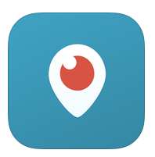
PERISCOPE
For viewers, Periscope gives you a new set of eyes and ears. Travel the world and step into someone else’s shoes. See what they see, hear what they hear, and hopefully feel what they feel. Watching a broadcast isn’t a passive experience like television. On Periscope, viewers influence the broadcaster by sending messages, and expressing their love by tapping the screen to send hearts.
INSTRUCTIONS:
- For Android & IOS (Apple iPhone) users go to the APP STORE & search for Periscope & download for free.
- If you have a twitter account you can log in using (recommended) that otherwise you can sign in with your phone number.
- Once installed – open the app and click on the icon at the bottom on the right hand side (3 people)
- Then click on the magnifying icon at the top left and search for our username: UkuleleClubLive (note all words begin with capital letters & have no spaces)
- When it comes up click on the add icon on the right side of the username & allow for notifications so that when we are about to go live you will be notified.
Our first braodcast will take place from 8pm on Thursday 9th July.
For Mac & PC users just click on the link below and download into iTunes:
https://itunes.apple.com/gb/app/periscope/id972909677?mt=8
Click on VIEW IN ITUNES just below the icon (it may ask for confirmation to open page)
There is a Twitter Help account if you get stuck.
https://twitter.com/periscopehelp
For more info about Periscope visit:
https://www.periscope.tv/
https://medium.com/@periscope

